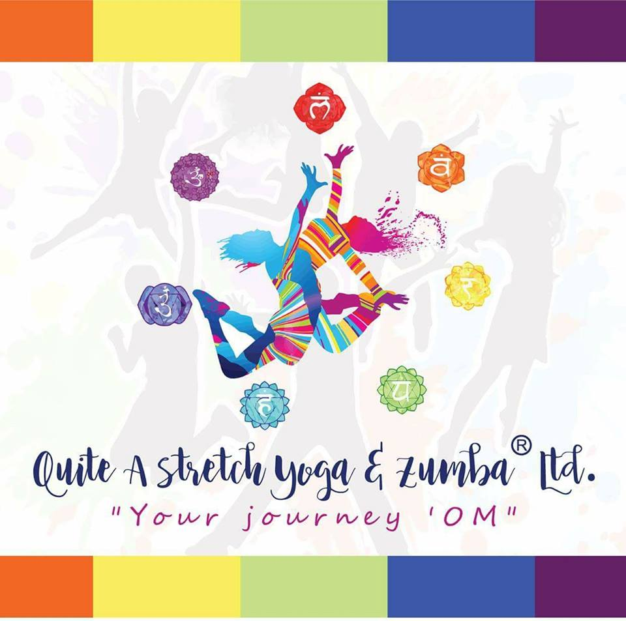

April 20, 2020 Update

Dear Quite A Stretch Yoga & Zumba Family:

The health and safety of our community is our top priority, and we ask for your assistance in keeping yourselves and others safe and healthy. STAY HOME

We are offering a FREE Yoga Nidra for your Inner Peace daily at 9pm. JOIN our FREE PRIVATE Facebook group at https://www.facebook.com/groups/QASONLINE/

We have been navigating our way through the information and predictions of our medical and scientific community. As such, we are abstaining from live classes where people gather for the safety of all.

Effective March 12, 2020, we will be temporarily closed until June 30, 2020

Personally, I am in the high-risk category and being advised to stay at home. I am feeling fine, and have no concerns for my own health at this time.

Please continue to find updated information on our Website, Facebook and Instagram pages Quite A Stretch Yoga & Zumba.

Thank you for your love and support. As a community we will be ok.

I will miss seeing you, but welcome hearing from you.
In gratitude and love,
Sheilah Laffan & the QAS Team

